Research Question (RQ) | The comfortable public narrative of “aging gracefully” in Singapore only works because it is built upon the invisible foundation of the countless sacrifices.  If vocation is what allows this harm to go uncounted, what does Singapore’s promise of “ageing gracefully” cost, and who has been quietly conscripted to pay it?
Source’s citation (see APA for more information)  Last name/s, First name initial. (DATE). Article title. Journal/newspaper/website. Pages/URL | Teo, Y. Y. (2019). This is what inequality looks like (New ed.). Ethos Books. | D'Ettorre, G., Pellicani, V., & Ceccarelli, G. (2020). Post-traumatic stress disorder symptoms in healthcare workers: a ten-year systematic review. Acta bio-medica : Atenei Parmensis, 91(12-S), e2020009. https://doi.org/10.23750/abm.v91i12-S.9459
Summary of Source (200 words each)  - Provide information about the source – type, author, context  - Sum up the source’s argument /claim/key ideas  - Paraphrase the most useful and relevant claims  - Recognise a concept/s that is related/ relevant to your topic/RQ and discuss it  - Include ONE essential quotation (short phrase or short sentence); make sure to cite the source. After this table, include a screenshot that shows where this quotation is in your source. | In her work, Teo (2019) Argues that inequality pervades Singapore. In this tiny island, two radically different realities can exist: a developed, cosmopolitan society, as well as a ghettoized “slums” with migrant worker dormitories and rental flats.  Her views, and arguments are grounded in fieldwork, as well as her academic background as a sociologist. Poverty cannot be understood isolated from inequality, wealth, privileges, the state’s involvement in this, meritocracy, as well as the very narratives we have built up and became comfortable with.  Teo argues that meritocracy is working the way it is intended: “convincing us that we all—no matter where we are on the social hierarchy— deserve to be exactly where we are. Those who cannot get their children to have qualities legible as merit pay its price.” (Teo, 2019).  However, caregiving skills do not qualify as “merit”. Healthcare staff, if they aren’t doctors, usually aren’t viewed upon as favourably, and nurses–particularly diploma holders–are viewed as lower status, due to a market-driven meritocracy, and naturally, they too obtain much lower compensation. Singapore has engineered meritocracy and where the low pay and precarity is justified, even though they are considered part of essential services.  (197 words)  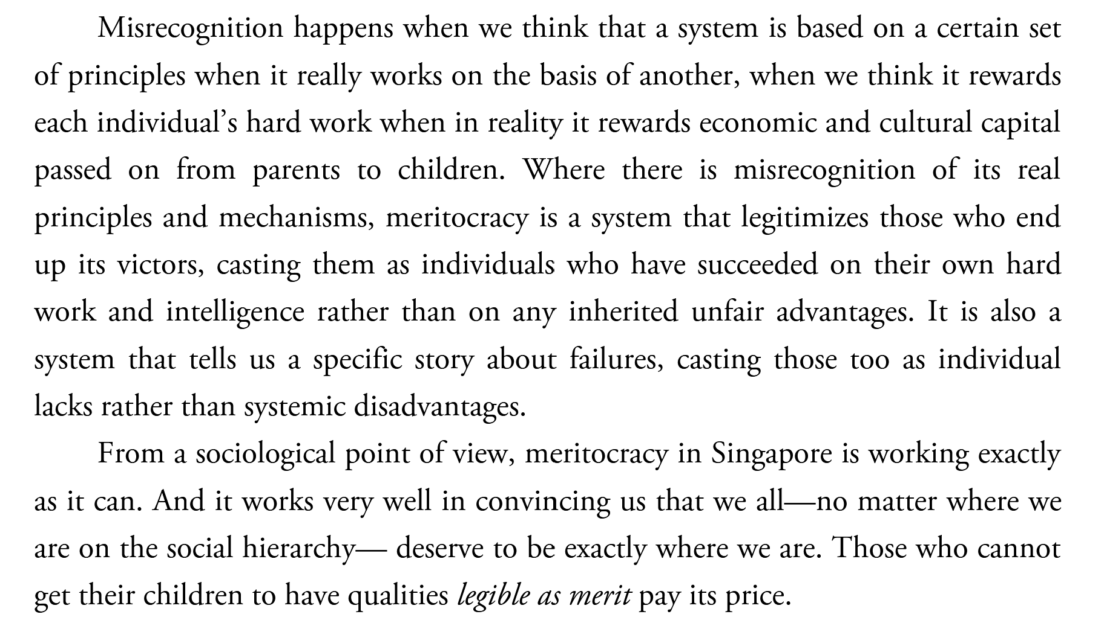 | d’Ettorre, Pellicani and Ceccarelli (2020) pens a peer-reviewed systematic review in the early stages of COVID-19 pandemic. By comparing and reviewing 32 studies across the decade (2010–2020) on post-traumatic stress disorder (PTSD) symptoms among healthcare workers, they have then sorted into risk assessment, risk management and occurrence rates. The authors then argue that PTSD is a serious occupational hazard for staff and institutions alike, because it is linked to burnout, moral injuries, physical mistakes such as medication errors and overall poorer outcomes. The prevalence varies, but it ranges up to 92%.  The authors note that “a relationship between PTSD symptoms and both age and length of service; based on these findings, the authors hypothesized that stressful experiences… therefore, this potential cumulative effect may explain why HCWs with PTSD symptoms were frequently older with more years of service rather than a young, inexperienced HCW.” (D'Ettorre, et al., 2020).  This counts towards the countless sacrifices that frontline workers bear in the process. While this peer reviewed study looks across 32 studies done globally, with none in Singapore, the symptoms appear to be consistent with my fieldwork notes, suggesting a worldwide phenomenon rather than it being strictly a Singapore occurrence.  (198 words)  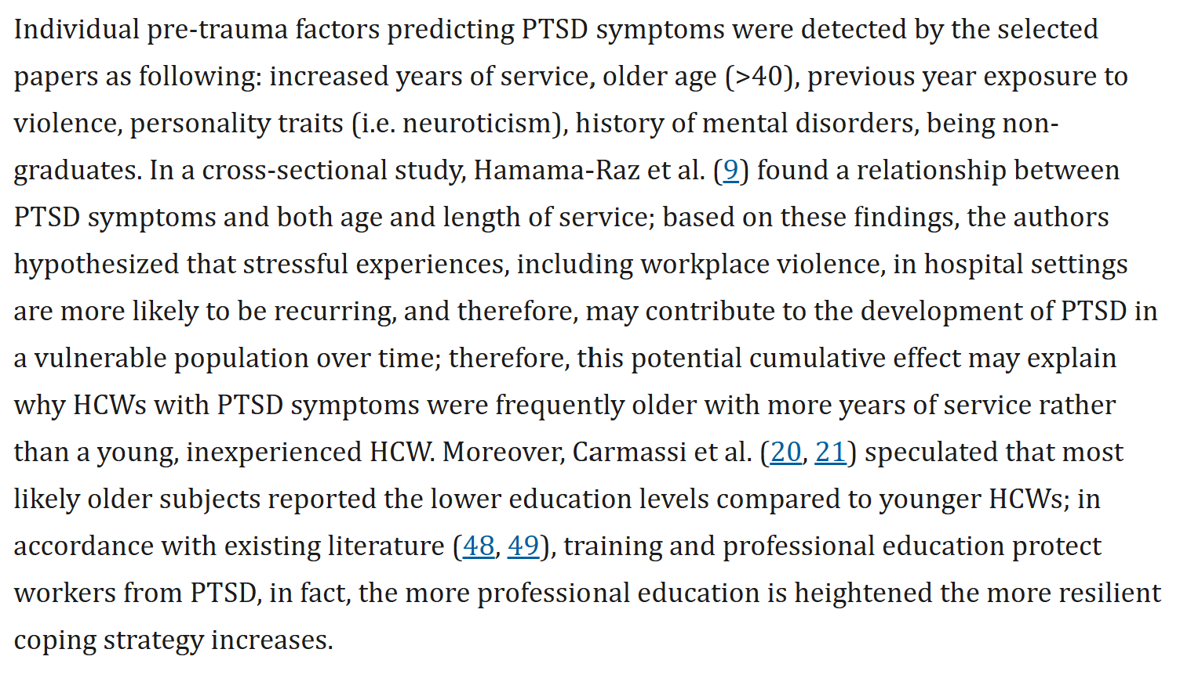
Engagement with Sources (150 words each)  - Apply: What claims or concepts respond to the RQ? Explain their relation to the RQ / your observations in A1.  - E.g.: Author (Year) reveals that the creativity I observed initially isn’t as easy to develop as we think…  - Evaluate: Are you convinced by the source’s claim or argument? How do its claims compare against your own lived experience?  - Is the source’s argument leaving something important out, or assuming something? What is it? (may not be applicable to a source, don’t force this!)  - What are some possible alternative arguments? (go back to your observations and analysis)  Important, but optional for now: Write a sentence that shows you moving beyond the source (revising its claims/concepts) to offer a more convincing response to the RQ. | Teo You Yenn (2019) discusses how Singapore’s approach to Meritocracy is fundamentally flawed although it is working as intended, as a sorting mechanism legitimizing social hierarchy and devaluing other abilities that cannot be viewed as “KPI”. In the context of my RQ, this could be linked to caregiving capabilities, and how healthcare workers are marginalized as a result, particularly beneath the narrative of graceful ageing. I have personally witnessed, and experienced it myself, the severe burnout, and the unattributable harm onto healthcare staff, with low pay, while framed underneath as a “calling”. Teo explains this as a structural phenomenon: Care labour lacks quantifiable metrics, thus sorting essential service workers into lower status tiers. Teo further argues that state narratives rely on low-wage, invisible labour to keep public infrastructure affordable: This checks out, Transitional Care Facilities operate on massive deficits, even when understaffed, and workers are paid low wages.  (148 words)  Teo’s (2019) arguments explain how Singapore has come to institutionalise and treat most things as market-driven, leading to a systemic outcome of underpaying essential service workers, including healthcare staff. Yet, that framework is borne out of a necessity, due to budget concerns, and broadly generalises the system at a populace level, with minimal personal input from each healthcare staff. While it is true that some of us enter the profession as we were forced to, some of us enter it willingly, and are not purely just victims of systemic exploitation. Healthcare professionals have pride in our profession and solidarity, and for some, even personal meaning that goes beyond just a career, in the truest of a sense, a “calling” per se. I would perhaps argue that healthcare workers are not just victims to a systemic exploitation, but agents whose intrinsic value must be redefined through other means beyond just “meritocracy”.  (150 words) | d’Ettorre et al. (2020) studies show that the harm my RQ says goes “uncounted”, on the contrary, can be counted. Their review finds that PTSD is common among hospital staff and is primarily caused by workload, inadequate training and poor support, and not personal weakness. This further backs that Singapore’s “ageing gracefully” narrative depends on healthcare workers absorbing unseen costs. The authors also note that older, longer-serving workers show higher risk, suggesting harm is cumulative. That fits my observation that those who carry the system longest are least acknowledged. Their finding that staff can feel “unvalued” under heavy workloads (reported from Lee et al.) also links directly to marginalisation. If ageing is delivered through hospitals, the review shows who bears the psychological cost of delivering it, and that the cost is documented but not reflected in public narratives.  (138 words)  While the source helps to back my claims that the harm is real and structurally produced, but it has limits. Thirty-one of the 32 studies were cross-sectional; thus causation is not established, and varying PTSD definitions explain the wide 2.2–24% range. The evidence comes mostly from emergency, trauma and psychiatric settings in Western or Chinese contexts. It does not contribute much regarding eldercare, nursing homes or migrant caregivers, who carry much of Singapore’s ageing burden. Furthermore, the review also views risk partly as individual vulnerability and proposes training and coping as a remedy, which risks placing responsibility for managing harm on workers themselves. It also never questions why harm is under-reported, which is where vocation matters: a calling can make suffering feel like duty, so it is not named. Maybe, it’s not that harm is unquantifiable, but it comes often too late when it is already done unto the victims.  (151 words)
Check: Are the key concepts of both sources different from each other? Do their ideas work together (new but relevant concepts emerged), challenge each other productively, or lead you into a fruitless debate? Why? | Both sources, Teo (2019), and d’Ettore et al. (2020) talk about very different matters, and they work together to give me more depth in answering my RQ. Teo explains why certain jobs are undervalued, and how it is primarily driven by demand-and-supply, resulting in a market-driven meritocracy that shortchanges every “merit” it fails to recognise, thus justifying low wages and social hierarchy. d’Ettore demonstrates what that undervaluation leads to, when cumulative, psychological harm, and in worst cases, PTSD and even death. Together, we can see that harm, is structurally produced, and structurally unrecorded. When recorded, it is often too late, as it has already been done unto the victims.  They also help to challenge each other. Teo mentions that individually, from a sociology standpoint, there is nothing much one can do. Similar to how low-income parents are viewed as having made “bad financial choices”, it would have been more accurate to say they were dealt a bad hand to begin with, suggesting that it’s a structural problem, and individuals can only make the best out of a bad situation. It is more of a structural problem, than an individual one. d’Ettore however challenges that, with common remedies be for self-improvement, coping, and training, and not so much of the lack of peer support or proper channels for guidance. While neither source addresses my RQ directly, regarding how Singapore has framed this as a “vocation” and a “calling”, which explains how healthcare workers bear the brunt of it quietly, this is where my own argument lies. Healthcare workers need better structural support. While we serve with pride and solidarity, that alone is insufficient in the face of time, systemic exploitation, and cumulative fatigue. Our intrinsic value needs to be redefined, and not just through “meritocracy”, but something more.

